National Coral Reef Monitoring Program

Climate Monitoring Brief: Dry Tortugas National Park

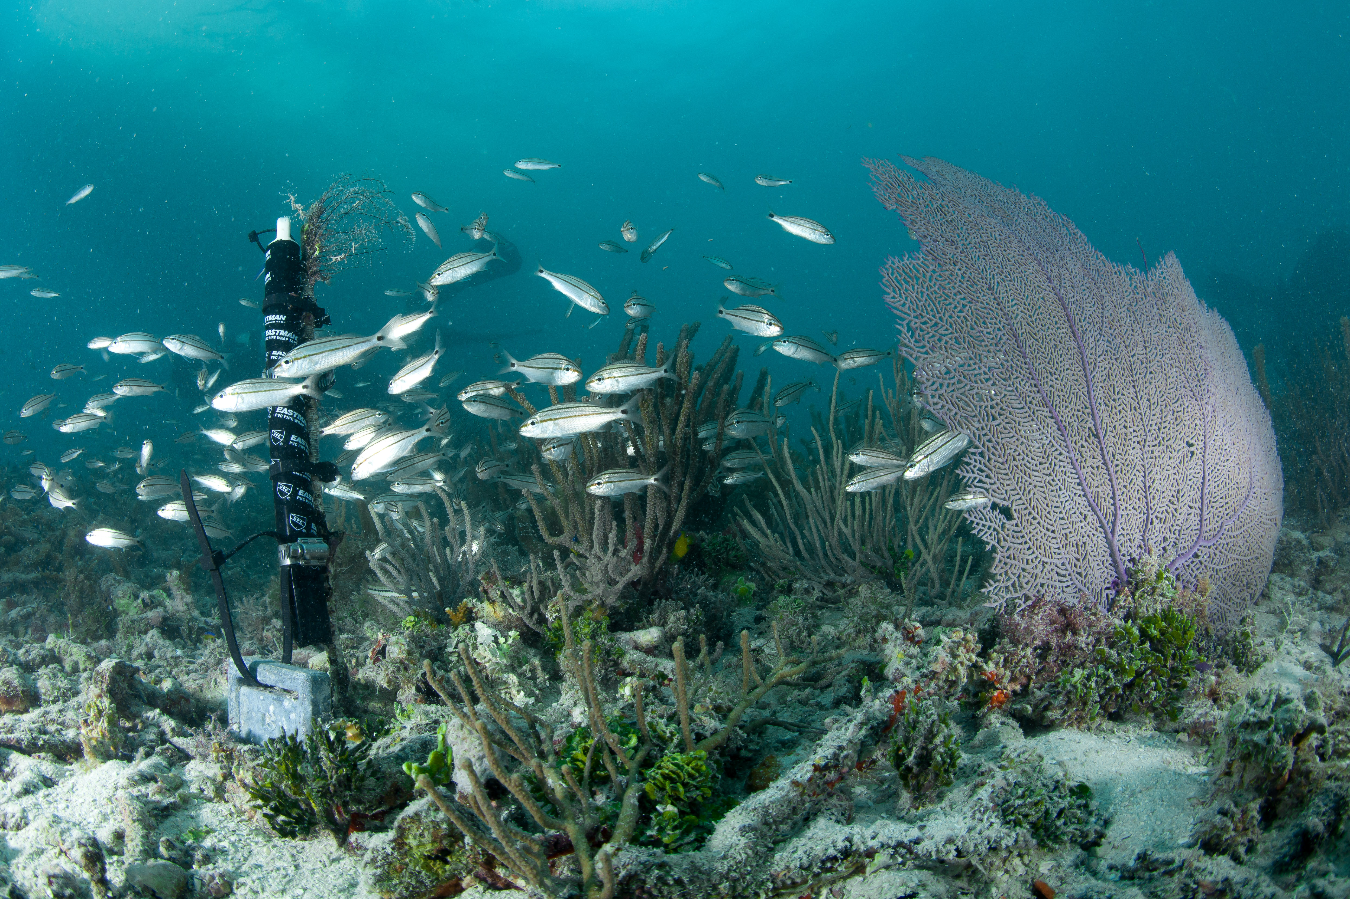

New Subsurface Temperature Recorder depolyed at White Shoal in Dry Tortugas National Park

Atlantic Oceanographic & Meteorological Laboratory Coral Program University of Miami Cooperative Institute of Marine and Atmospheric Science National Oceanic Atmospheric Administration

N. Besemer, A. Palacio, M. Jankulak, G. Kolodziej, I. Enochs - July 2021

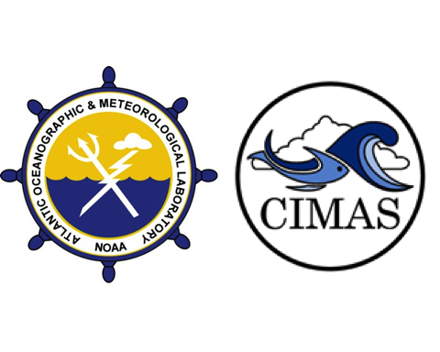

### About this summary brief

The NOAA Atlantic Oceanographic and Meteorological Laboratory (AOML) conducts the long-term National Coral Reef Monitoring Program (NCRMP) to track the status and trends of coral reef ecosystems of the U.S. Atlantic and Caribbean coral reef jurisdictions. This FY21 summary brief provides an overview of the most recent survey efforts.

### Expedition summary

* The most recent NCRMP Atlantic climate monitoring took place at Dry Tortugas National Park from June 24th to June 29th 2021
* Four different sites were visited by 5 team members completing a total of 63 dives.
* These sites represent temporal‐resolution monitoring with moored instruments at fixed time‐series which are placed on depth gradient to assess how vertical structure affects reef status and trends.

### Data collection

* Subsurface **temperature** recorders (STRs) were recovered at all 4 study sites, accounting for 1.1 million temperature observations:
  + Pulaski Shoal (1m): 311,609 observations
  + White Shoal (5m): 311,213 observations
  + Bird Key Reef (15m): 311,560 observations
  + Black Coral Rock (25m): 165,695 observations
* At the Bird Key Reef, short term instruments (72h) were deployed to monitor daily fluctuations in:
  + **Current**: 880 observations
  + **pH**: 879 observations
  + **Light**: 876 observations
* Additionally, changes in benthic cover and carbonate production were monitored at Bird Key Reef by recording:
  + **Bioerosion**: 5 Bioerosion Monitoring Units (BMUs),
  + **Calcification**: 5 Calcification Accretions Units (CAUs)
  + **Benthic cover**: 6 landscape mosaics
  + **Carbonate budget surveys**: 6 BL BLA BLA

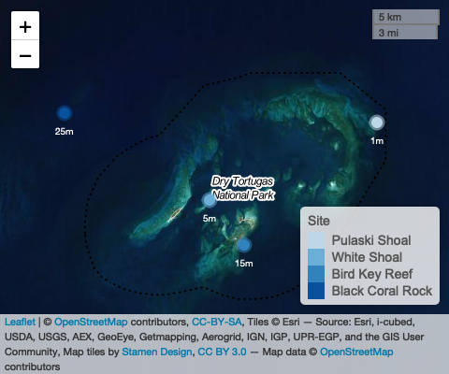 **Figure 1:** Map of study sites in Dry Tortugas National Park area

#### Temperature

Three years of temperature measurements were retrieved and processed from all 4 sites (depths). Temperature was measured using SeaBird Electronics Subsurface Temperature Recorders (STR)s that collected data at 5-minute intervals.

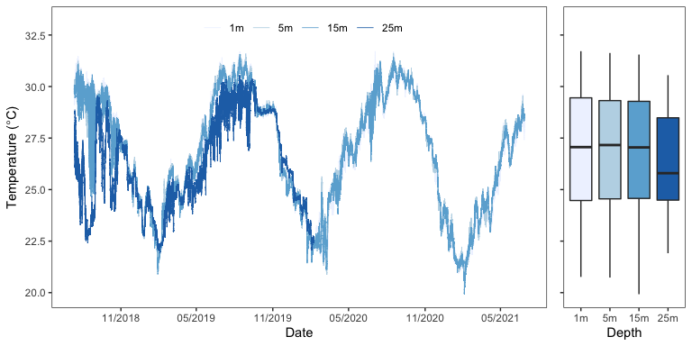

**Figure 2:** Temperature conditions at four sites in the Dry Tortugas representing a depth gradient: Pulaski Shoal Lighthouse (1m) White Shoal (5m), Bird Key Reef (15m), and Black Coral Rock (25m). Data were collected from November 2018 to June 2021, with the exception of the 25m STR that recorded until February 7th 2020.

Temperature values were similar among the 1m, 5m and 15m depths with the lowest temperatures recorded during February 2021 (20.8, 20.7, and 19.9 $​^{∘}$ C, respectively) and the the higest temperatures during the summer of 2019 and 2020 (31.7, 31.6, and 31.5 $​^{∘}$ C, respectively). The 25m STR detected consistent temperature stratification at this site during the summers when it was active. Temperatures were XX to YY $​^{∘}$ C below the values at other depths.

#### Diurnal Suite Deployment

At Bird Key Reef additional instruments were deployed for a 72-hour diurnal suite that monitored pH, temperature, light and current speed. SeaFET pH logger, Tiltmeter and EcoPAR collected measurements at 5-minute intervals.

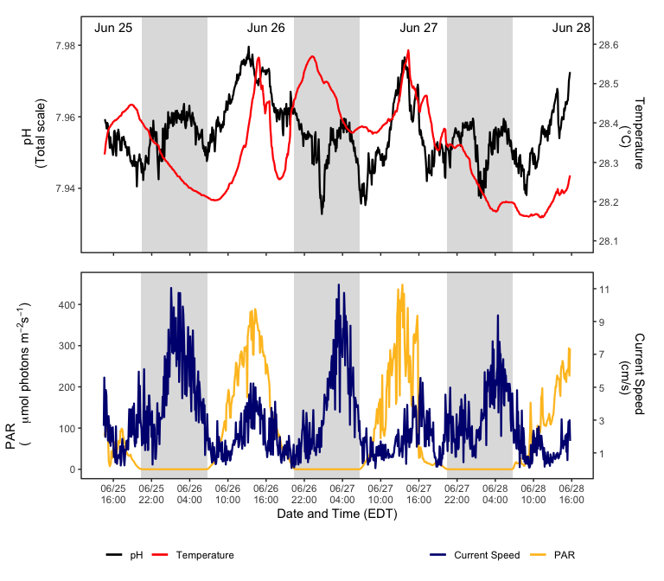

**Figure 3:** Bird Key Reef (15m) diurnal suite monitoring from June 25th to 28th. Top panel: pH and temperature. Bottom panel: current speed and Photosynthetically Available Radiation (PAR). Grey blocks denote night time throughout sequence of plot. Instruments measured parameters every 5 minutes.

As part of the diurnal suite, discrete water samples were collected at three-hour intervals (n=24) using Subsurface Automatic Samplers (SAS). THIS SAMPLES WILL BE ANALIZED TO ASSESS BLA BLA BLA

MAYBE ADD A PICTURE IF THE SAS AND OR LINK TO SAS PAGE

#### Other Deliverables

* **Calcification Accretion Units (CAUs)** and **Bioerosion Monitoring Units (BMUs)** were collected and redeployed for the next sampling cycle. CAUs are processed by the Pacific Climate group and the data will be available within a year. BMUs will be dried and cleaned using a hydrogen peroxide solution. These samples will be weighed and scanned using a Macro CT scanner and then compared to their pre-scans to quantify bioerosion. Data will be available in a year. Please reference previous datasets for more information.

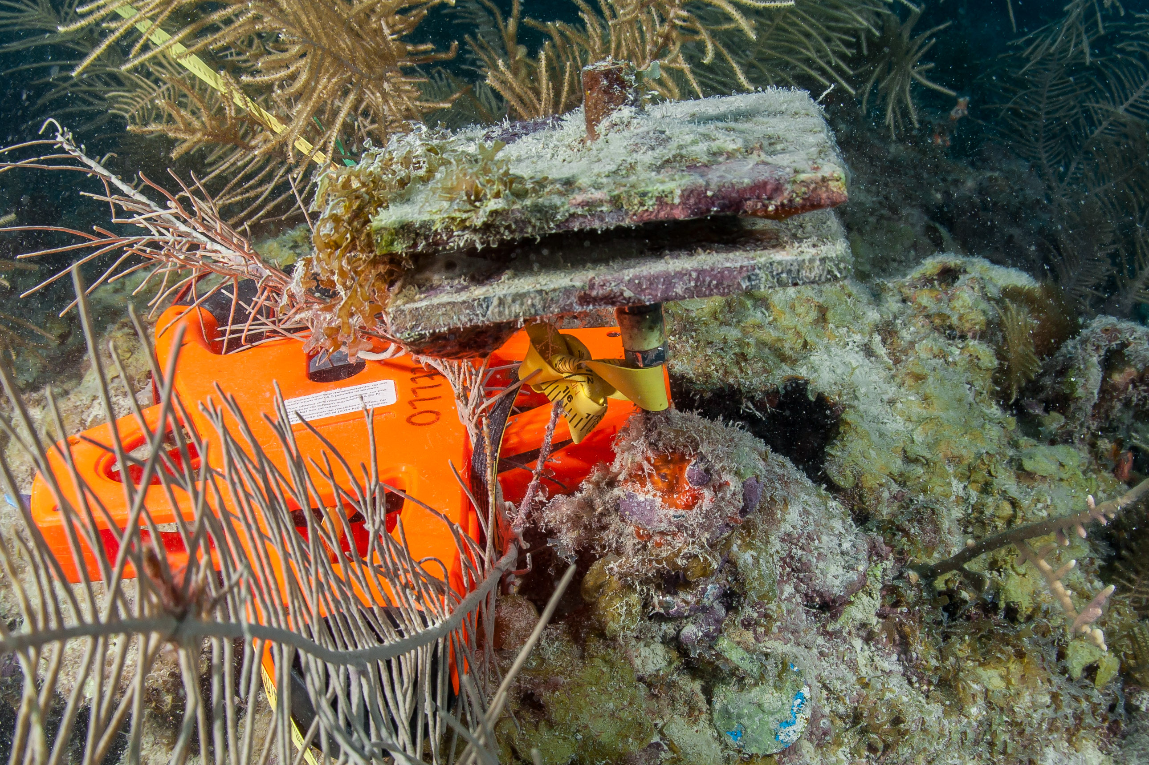

CAU and BMU pair after being deployed for 3 years

**Figure 4:** CAU and BMU pair after being deployed for 3 years WHAT IS ON THE TOP AND BOTTOM? DESCROBE THE PICTURE BETTER

* **Landscape mosaics** (n=6) and **carbonate budget** surveys (n=6) were completed to monitor changes in benthic cover and carbonate production

### About the monitoring program

AOML’s climate monitoring is a key part of the National Coral Reef Monitoring Program of NOAA’s Coral Reef Conservation Program (CRCP), providing integrated, consistent, and comparable data across U.S. Managed coral reef ecosystems. CRCP monitoring efforts aim to:

* Document the status of reef species of ecological and economic importance.
* Track and assess changes in reef communities in response to environmental stressors or human activities.
* Evaluate the effectiveness of specific management strategies and identify actions for future and adaptive responses.

### Point of Contact

Atlantic Climate team lead: [nicole.besemer@noaa.gov](mailto:nicole.besemer@noaa.gov)

Principal Investigator: [ian.enochs@noaa.gov](mailto:ian.enochs@noaa.gov)

NCRMP Coordinator: [erica.towle@noaa.gov](mailto:erica.towle@noaa.gov)

### For more information

Coral Reef Conservation Program: <http://coralreef.noaa.gov>

NCRMP climate monitoring: <https://www.coris.noaa.gov/monitoring/climate.html>

NOAA Atlantic Oceanographic and Meteorological Laboratory: <http://www.aoml.noaa.gov/>

[Florida Coral Reef Status Report 2020](https://www.coris.noaa.gov/monitoring/status_report/docs/FL_508_compliant.pdf)

### Acknowledgements

These efforts were jointly funded by NOAA’s CRCP and OAP. We would like to thank the National Park Service and Florida Keys National Marine Sanctuary for permitting support and the ANGARI Foundation for field support.

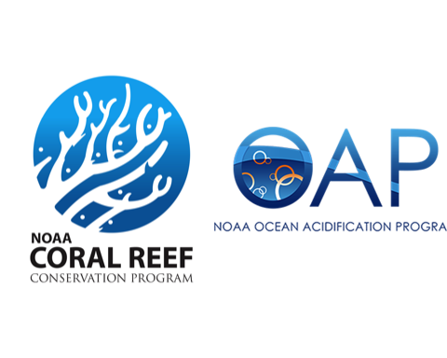

### Our Team

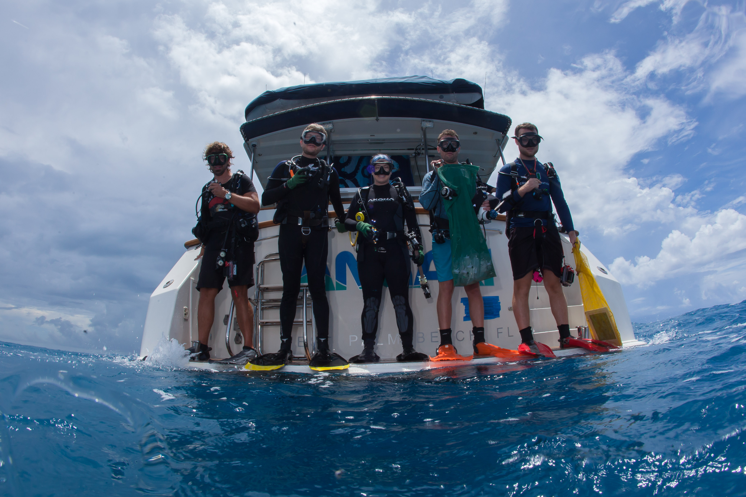

**Field team members**: Anderson Mayfield, Graham Kolodziej, Nicole Besemer, Nathan Formel, Patrick Kiel